**Embedded C Project**

1. **ABSTRACT: -**

I have demonstrated 8 simple LED based projects using ATmega328 microcontroller. ATmega328 is an eight bit AVR (Advanced Virtual RISC) based microcontroller.

It is a powerful microcontroller with a built-in internal memory of around 32Kb. Most Arduino boards consist of an Atmel 8-bit AVR microcontroller with varying amounts of flash memory, pins, and features. Arduino Uno is a microcontroller board based on the ATmega328. AVR microcontrollers are very easy to use.

All AVR microcontrollers require Integrated Development Environment(IDE) such as Atmel Studio. Using this IDE, we can create, compile and debug program on all AVR microcontrollers.

1. **REQUIREMENT: -**

**2.1 Microcontroller ATmega328**

* ATmega328 is an 8-bit, 28-Pin AVR Microcontroller, manufactured by Microchip, follows RISC Architecture and has a flash-type program memory of 32KB.
* Atmega328 is the microcontroller, used in basic Arduino boards i.e Arduino UNO, Arduino Pro Mini and Arduino Nano.
* It has an EEPROM memory of 1KB and its SRAM memory is 2KB.
* It has 8 Pins for ADC operations, which all combine to form PortA ( PA0 – PA7 ).
* It also has 3 built-in Timers, two of them are 8 Bit timers while the third one is 16-Bit Timer.
* Arduino UNO is based on atmega328 Microcontroller. It’s UNO’s heart.
* It operates ranging from 3.3V to 5.5V but normally we use 5V as a standard.
* Its excellent features include cost-efficiency, low power dissipation, programming lock for security purposes, real timer counter with separate oscillator.

**2.2 Led**

A Light Emitting Diode (LED) is a semiconductor device, which can emit light when an electric current passes through it. To do this, holes from p-type semiconductors recombine with electrons from n-type semiconductors to produce light. The wavelength of the light emitted depends on the bandgap of the semiconductor material. Harder materials with stronger molecular bonds generally have wider bandgaps. Aluminum Nitride semiconductors are known as ultra-wide bandgap semiconductors.

**2.3 Fixed Voltage**

A fixed output power supply has, well, a fixed output voltage. This means that when the power supply is plugged in and the output is on, the output voltage is a single voltage that is not expected to change – it is fixed at that voltage. These power supplies are typically used to provide simple bias for a circuit.

**2.4 Relay**

A Relay is an electrically operated switch. Relays are the switches which aim at closing and opening the circuits electronically as well as electromechanically. It controls the opening and closing of the circuit contacts of an electronic circuit. When the relay contact is open (NO), the relay isn’t energize with the open contact. However, if it is closed (NC), the relay isn’t energize given the closed contact. However, when energy (electricity or charge) is supplied, the states are prone to change.

**2.5 Buzzer**

Buzzers are electric sounding devices that generate sounds. Typically powered by DC voltage, they can be categorised as Piezo buzzer and magnetic buzzer. They come in different designs and uses as well, and based on that, they can produce different sounds.

1. DESIGN: -

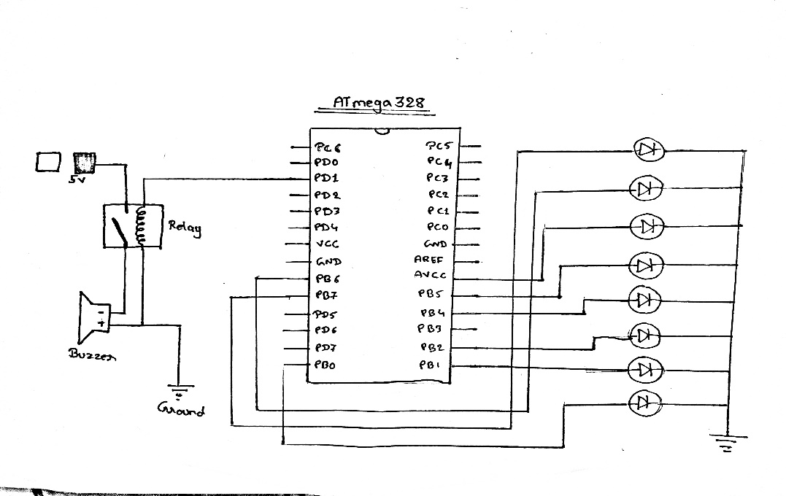

1. OUTPUT: -

